**PJ 8 Report My Name: _Yaowei Lei_**

**A. The following is my Python source program:**

**// Please copy your source program into here from your Visual Studio IDE.**

**// Your code here must be in color. You must not show screen prints here.**

#------------------------------------------------------------------------------------------------------------.

# Author: Yaowei Lei

# Date: 11/28/2021

# Purpose: CS119-PJ8: Number Game – keep accepting 3 integer, and output these 3 numbers in ascending order,

# the sum, and the average of these 3 numbers.

#------------------------------------------------------------------------------------------------------------.

# return the maximum of these 3 integer parameters

def max (p, q, r) :

if(p >= q) :

if(p >= r) :

return p

else :

return r

elif (q >= r) :

return q

else :

return r

# return the minimum of these 3 integer parameters

def min (p ,q , r) :

if(p <= q) :

if(p <= r) :

return p

else :

return r

elif (q <= r) :

return q

else :

return r

# return the middle of these 3 integer parameters

def mid (p, q, r) :

if(p >= q) :

if(q >= r) :

return q

else :

return r

elif(p >= r) :

return p

else :

return r

# return the sum of these 3 integer parameters

def sum (p, q, r) :

return (p + q + r)

# return the average of these 3 integer parameters, can call sum(p, q, r) here.

def avg (p, q, r) :

return sum(p, q, r)/3

# Beginning of MAIN PROGRAM ============================================.

n = 1 # line number for each separator line

print ("Welcome to the Number Game of Yaowei Lei!")

print (n,"============================================================"); n+=1;

while True: # keep running forever. It must be stopped by a break inside the loop.

p = int(input("Enter first number: ")) # input the first number as a integer

q = int(input("Enter second number: ")) # input the second number as a integer

r = int(input("Enter third number: ")) # input the third number as a integer

# stop program when the first number from the user is -777.

if (p == -777) :

break

print ("You just entered 3 integers: ", p, q, r)

print ("These 3 integers in order are ", min(p, q, r), mid(p, q, r), max(p, q, r))

print ("Their sum is ", sum(p, q, r), " and their average is ", avg(p, q, r))

print (n,"============================================================"); n+=1;

print (n,"============================================================"); n+=1;

print("Thank you for playing this Number Game of Yaowei Lei!")

print (n,"============================================================"); n+=1;

# End of MAIN PROGRAM ============================================.

**B. The following is the console output of my 3 test runs:**

**// One way to copy the console output is to press Ctrl+Alt+PrtScn.**

**// Another way to copy is to use the snipping tool. To paste the image is to press Ctrl+v.**

**// The console display must not be too wide, otherwise it will be too hard to read once pasted.**

**// Please make sure your console is long enough to show all your output lines to be captured.**

**// Please copy your console output and paste into here:**

**Test Case #1:**

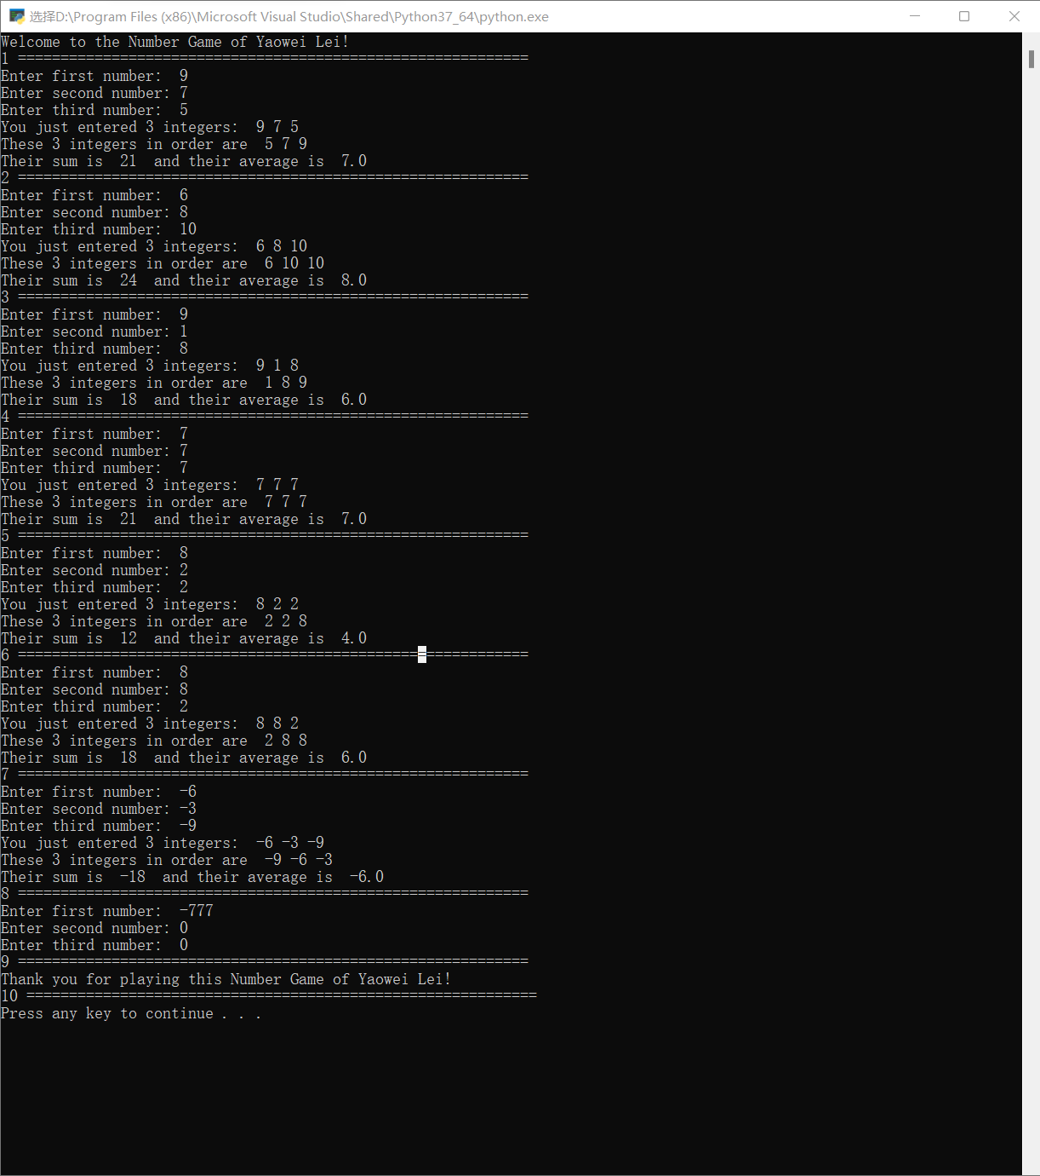

**Test Case #2:**

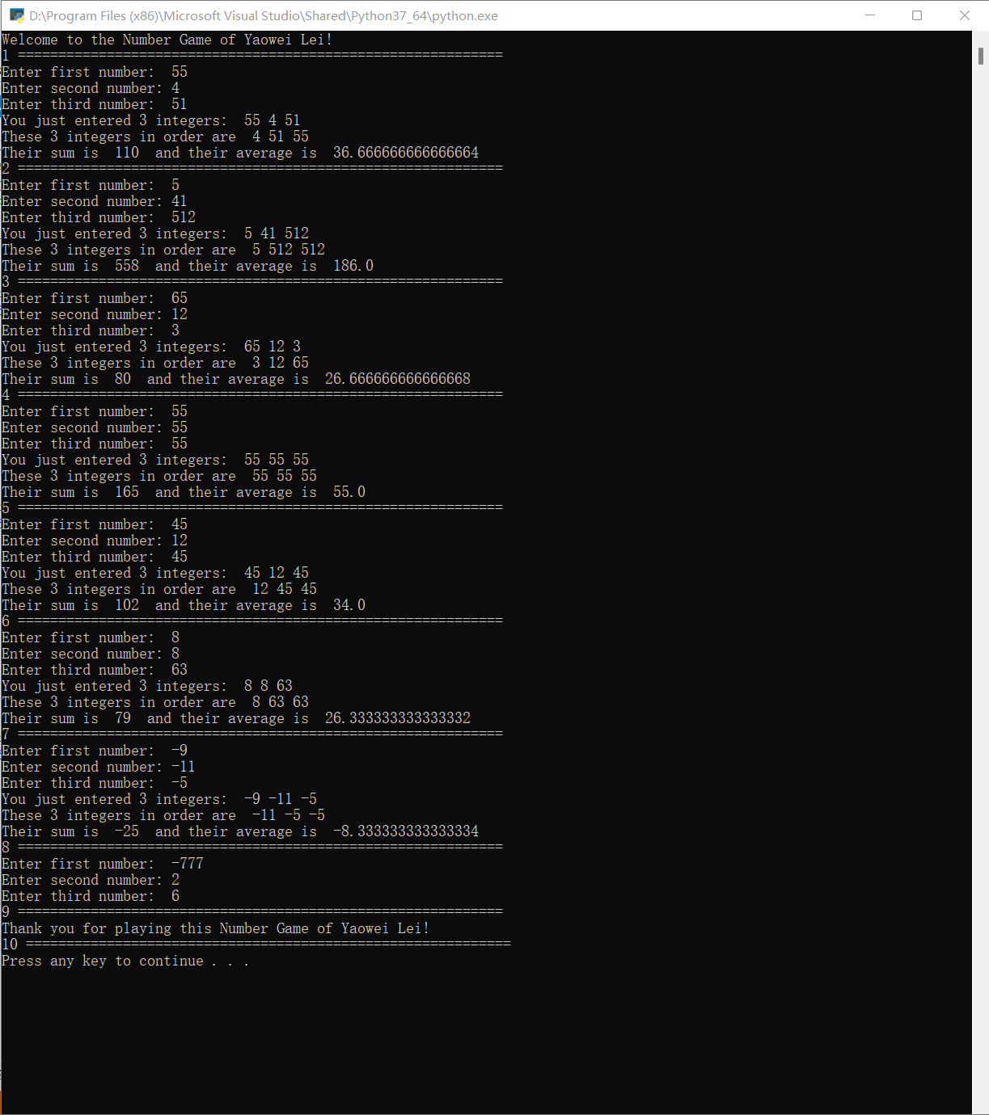

**Test Case #3:**

